This report details how I tried to implement the necessary security fixes and the steps taken to fix the vulnerabilities observed through the Nessus Advanced and Nmap scans. The Nmap scan helps discover the open ports and the services running on the ports. In contrast, the Nessus scan of the Metasploitable machine (10.0.69.10) helped find outdated software, required configuration settings, and weak patches on the machine.
Found the open ports using nmap scan : -A -sV 10.0.69.10
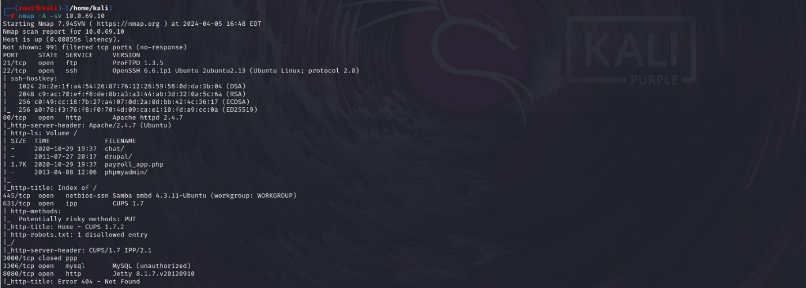
And found vulnerabilities using the Advanced Scan using Nessus (Metasploitable scan_Vulnerability Pre-Fix Scan, n.d.) as per the screenshot provided below.
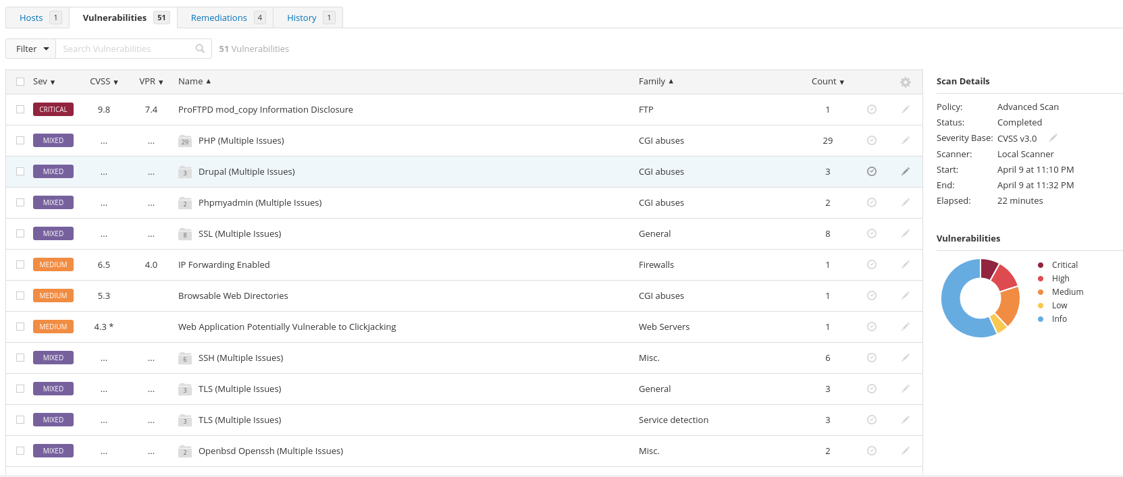
I managed to fix a few vulnerabilities related to

- Network services: FTP, SSH
- Web applications: SQL injection, Drupal Coder deserialization RCE.
- System services: SMB, IP forwarding.
- Outdated software versions: Php, drupal version
- Browsable Web Directories,Web Application Clickjacking, Php outdated software

Network Services:

FTP: ProFTPD mod_copy Information Disclosure
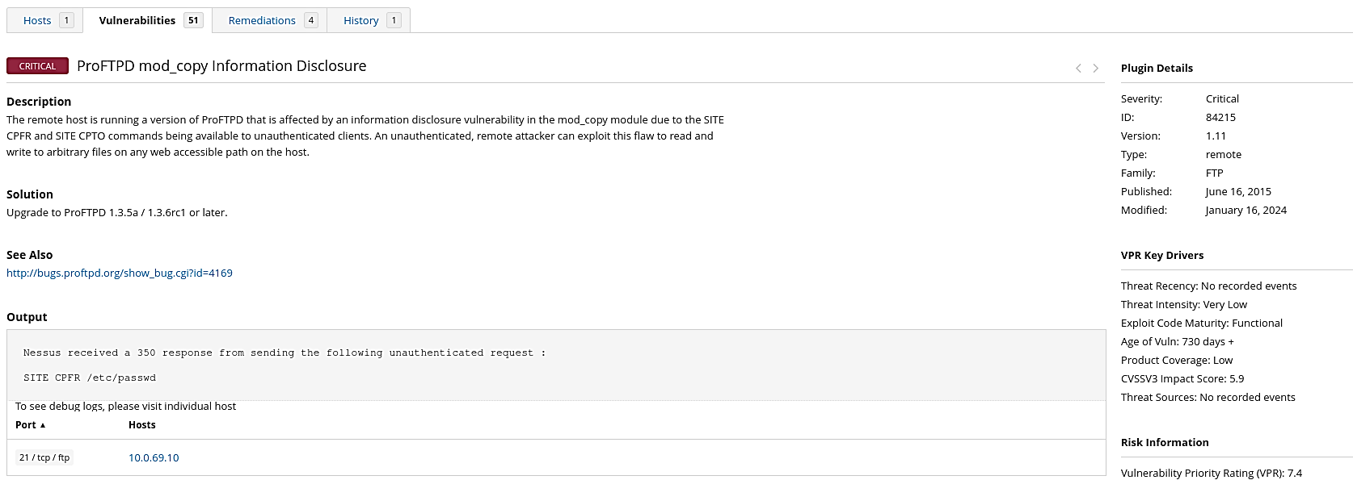
The solution to fix this vulnerability has been to upgrade the proftpd to a more recent version of proftpd 1.3.5a/1.3.6 or later.I used the command sudo apt-get install proftpd
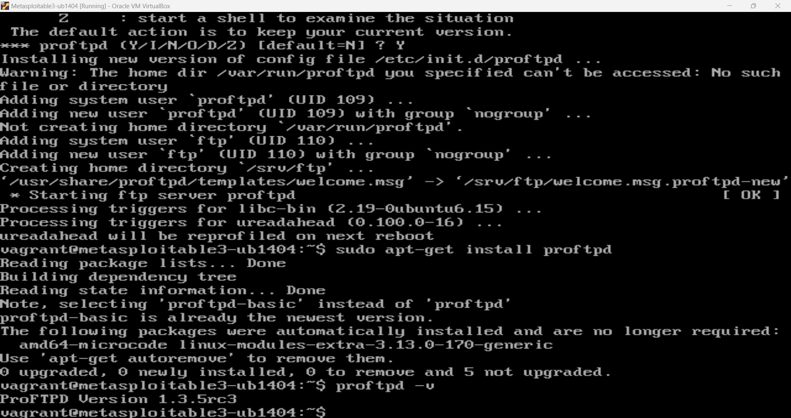

The above screenshot shows that the proftpd version is now updated which fixed the vulnerability related to FTP.

SSH: SSH Weak Algorithms supported

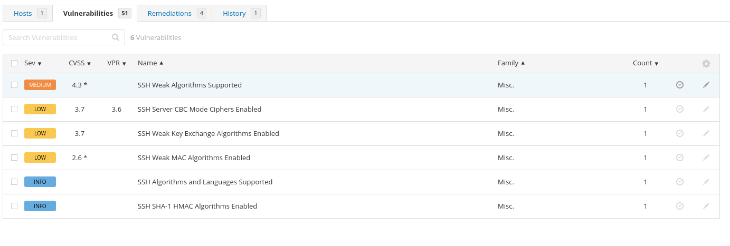
After Nessus detected that the remote SSH server was using weak or no cipher for encryption, including the Arcfour stream cipher, I fixed this issue by configuring the SSH server to use strong ciphers and MACs (message authentication codes). I opened the SSH configuration file at /etc/ssh/sshd_config and added.
Ciphers arcfour, arcfour256, arcfour128
MACs hmac-sha1, umac-64@openssh.com, hmac-ripemd160.
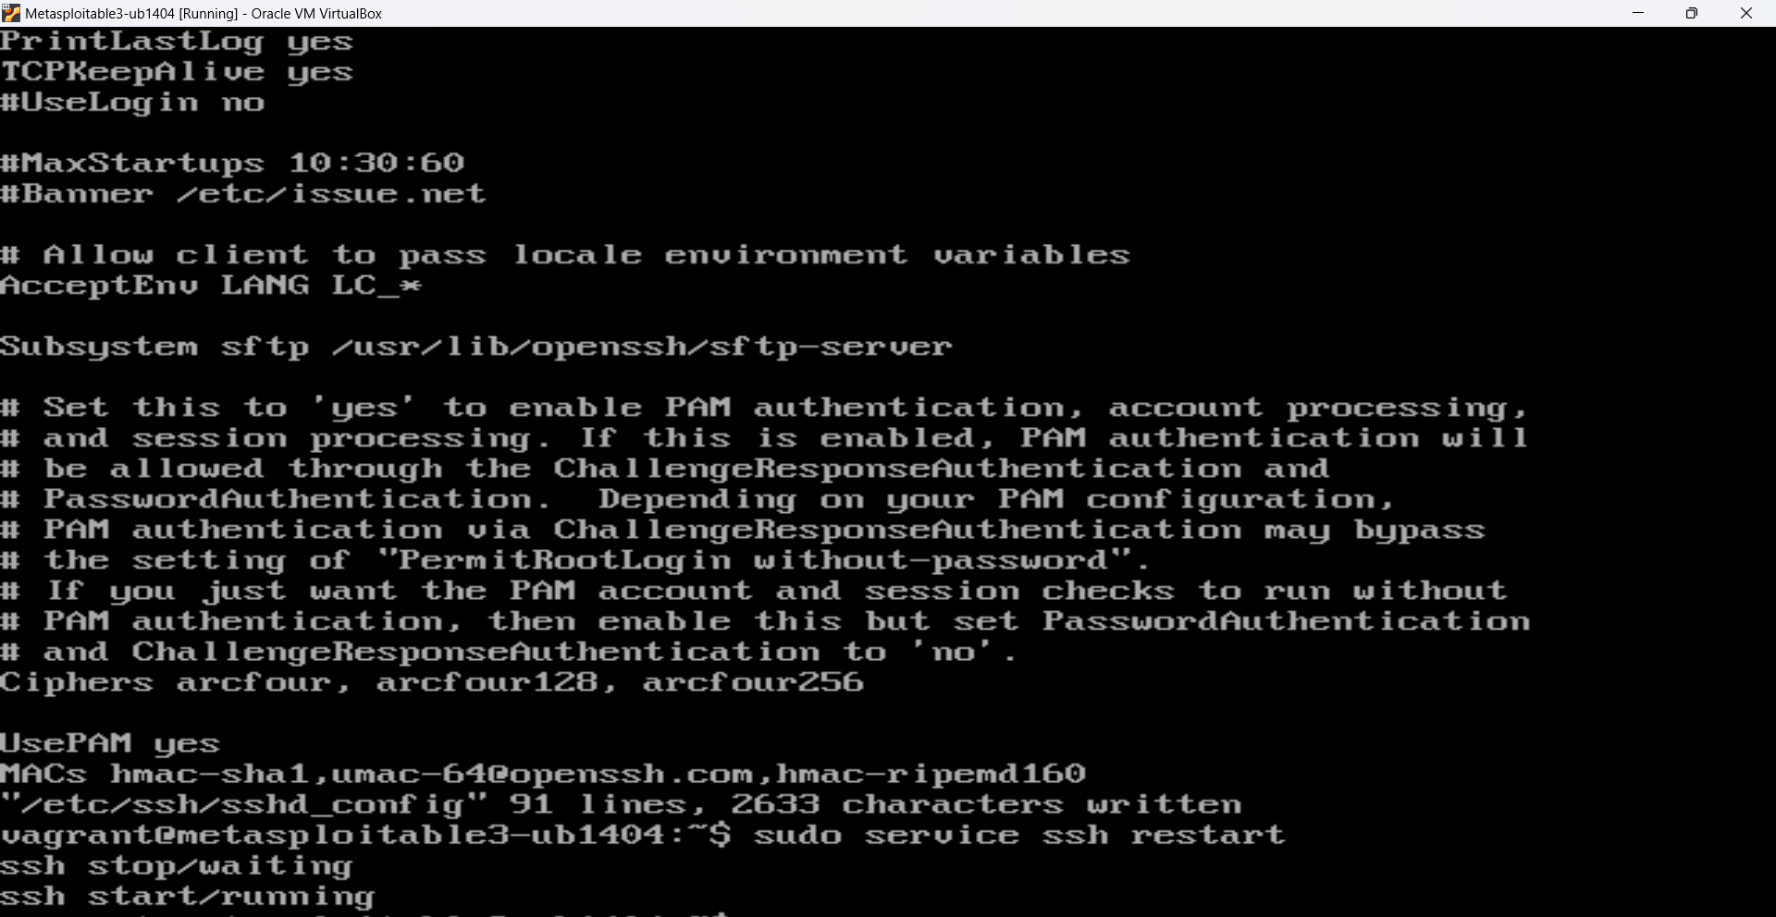
Once the configuration was updated, I saved the file and restarted the SSH service to apply the changes.

Web applications:

SQL injection: PhpMyAdmin

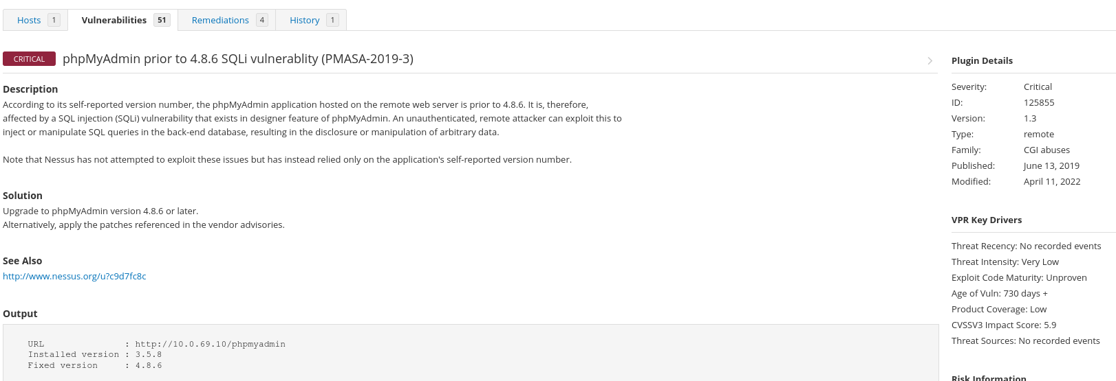

I updated phpMyAdmin to the most recent version in order to fix the SQL injection vulnerability present in versions of phpMyAdmin lower than 4.8.6. I downloaded the most recent phpMyAdmin package and unzipped the files, then made a backup of the current installation and database.
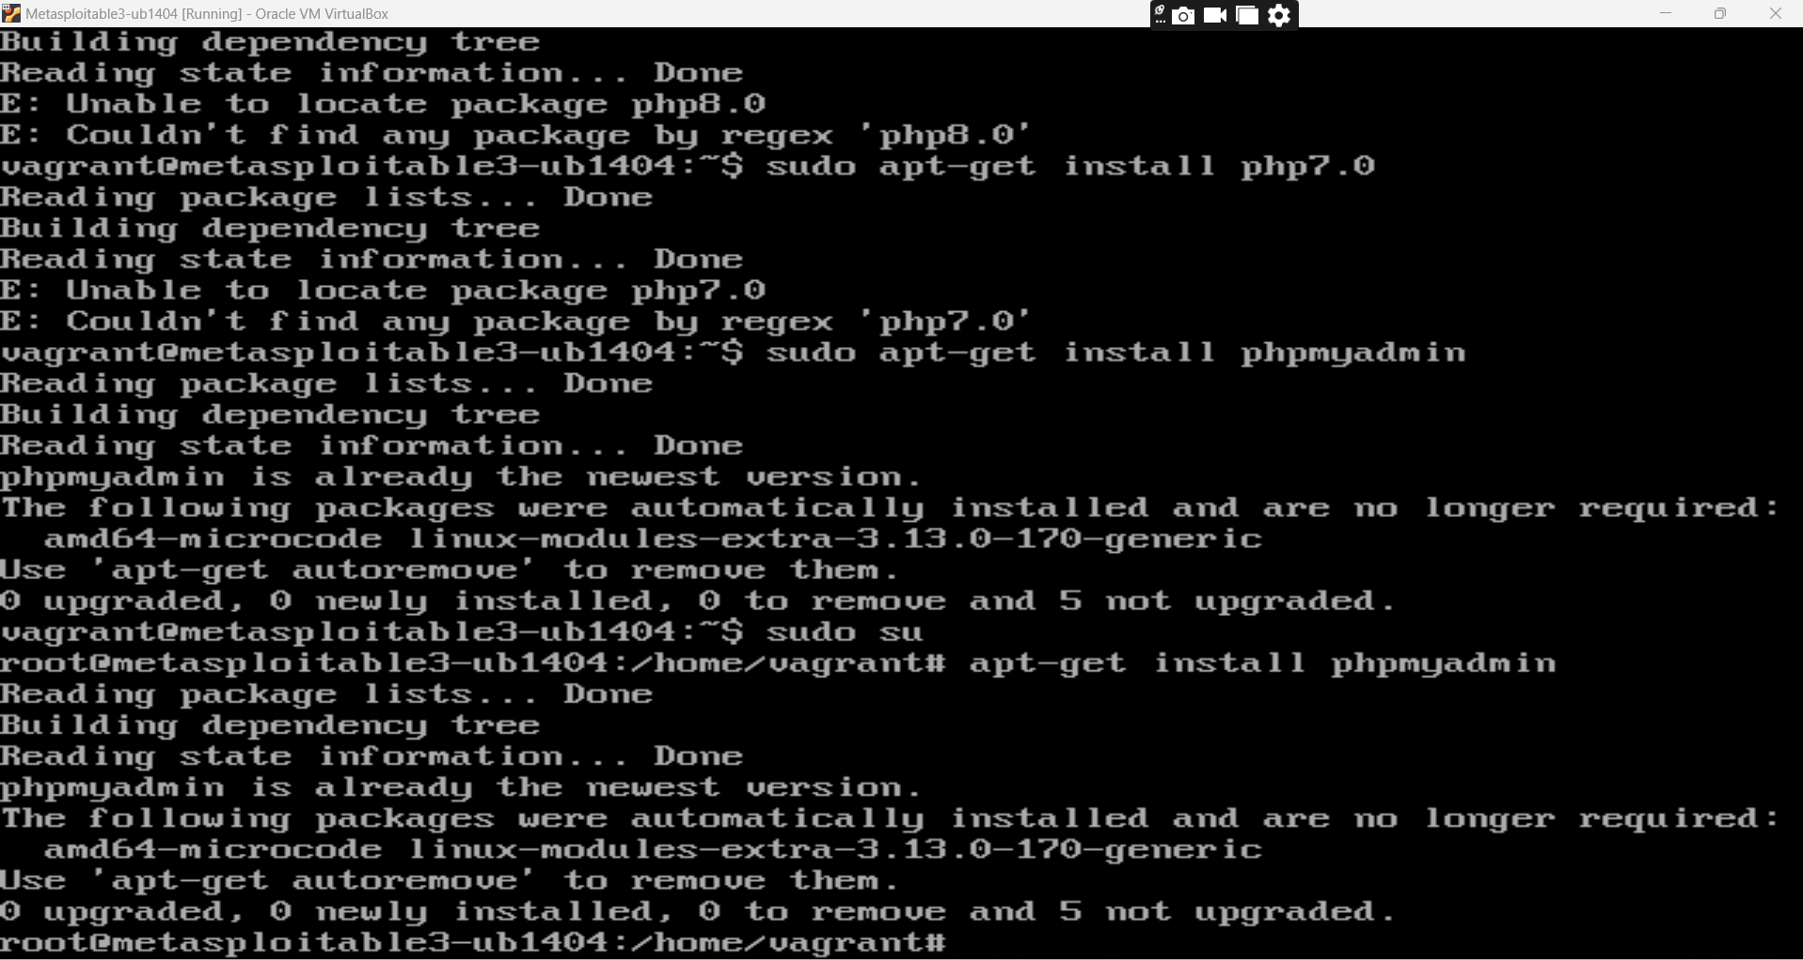

Drupal Deserialization RCE:
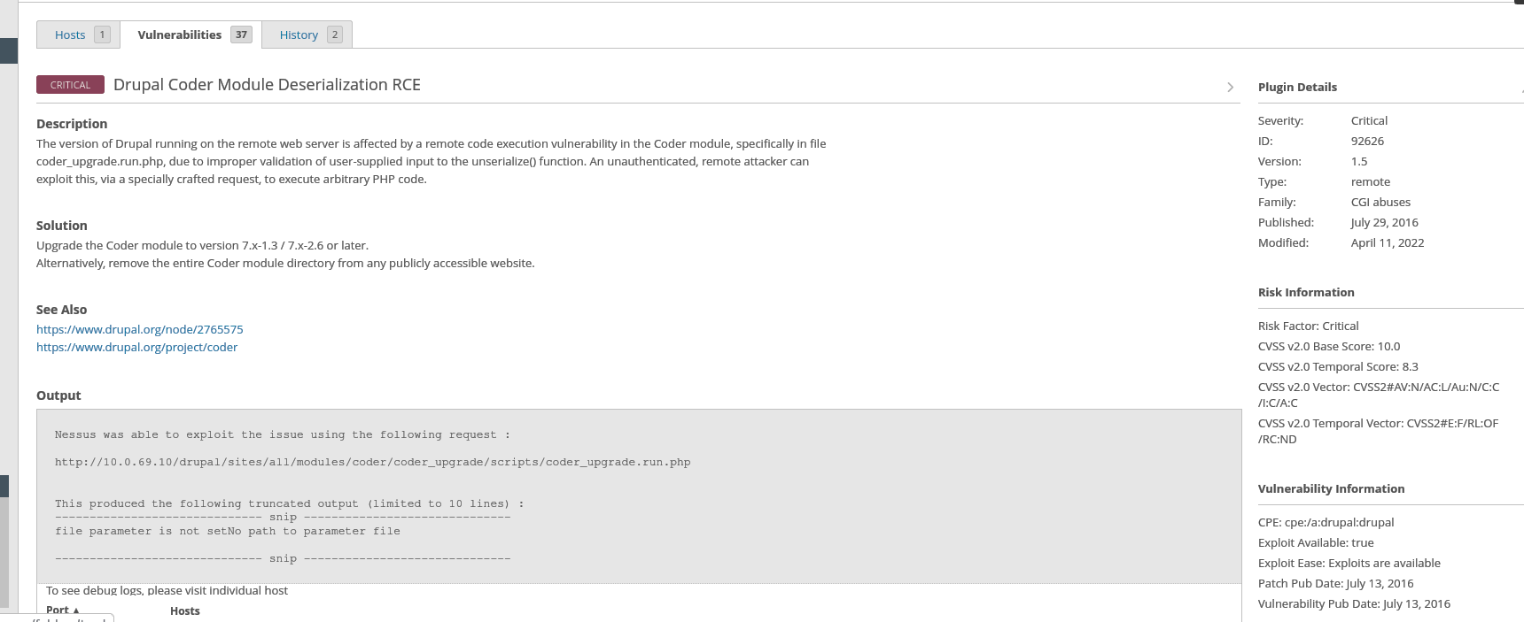

I disabled the existing coder module and downloaded the tar file for the most recent version of the Coder module, which is 7.x-2.6, using the wget command. After downloading, I used the tar -xzf command to extract the tar file; then I went to the /var/www/html/drupal/sites/all/modules directory to access the Drupal coder installation. 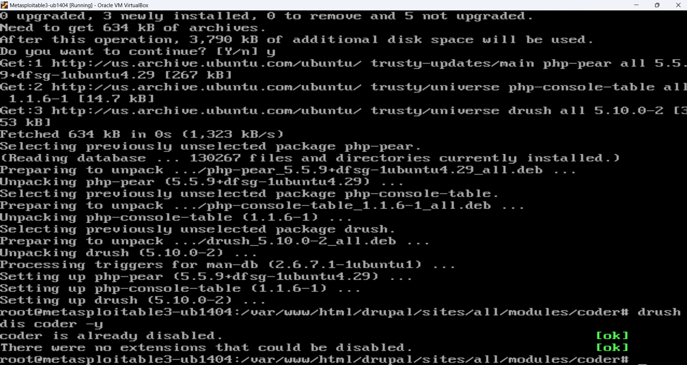
Lastly, I moved the Coder module files that had been extracted into my Drupal installation's modules directory of /var/www/html/drupal/sites/all/modules/coder 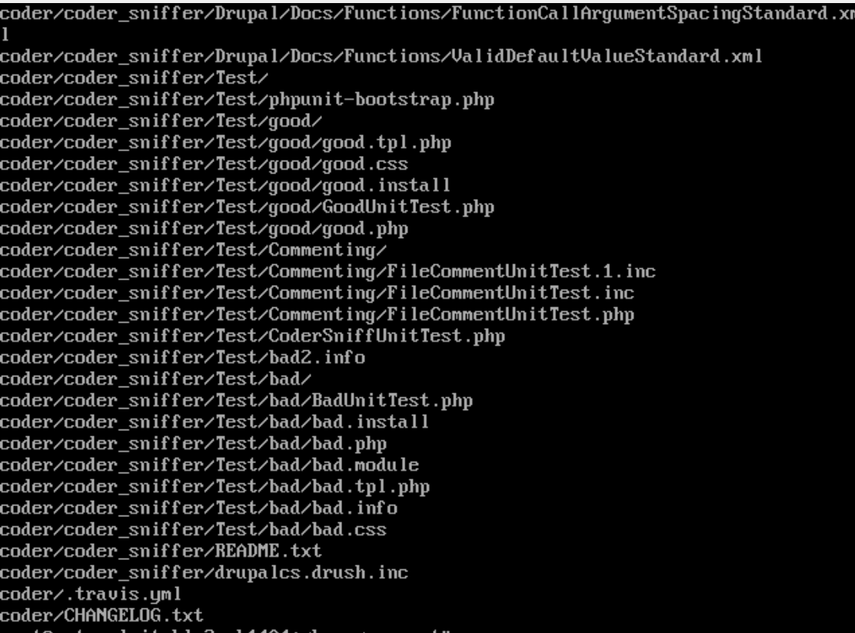

System services:

SMB: SMB Signing not required.

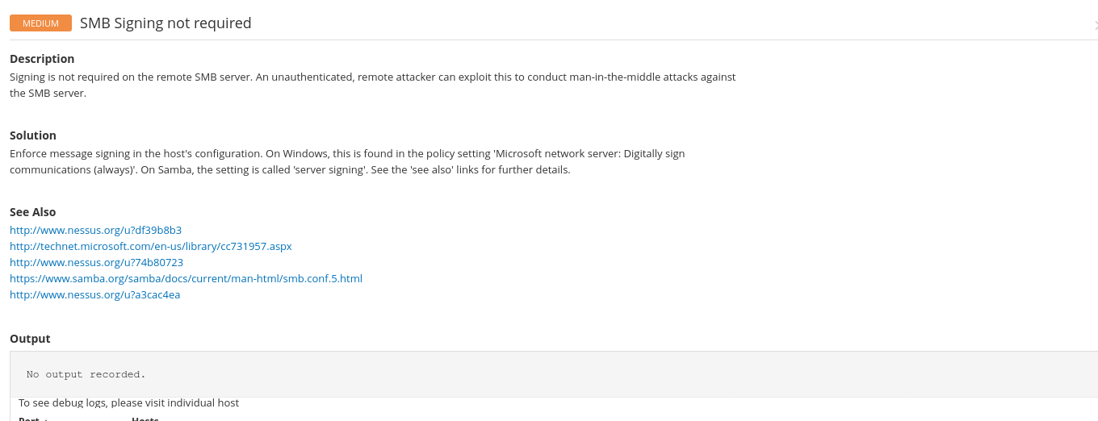

I first checked to see if I have samba services installed or not using “apt install samba -y” and once ensuring it is available I checked the service to start and the status using the command “service samba start/status” in super user mode and then used edited the samba.conf using “nano /etc/samba/smb.conf” command and then In global, I entered lines with “server signing = mandatory and client signing =mandatory.” And saved and restarted the samba service as shown below this solved the issue of signing not being required.

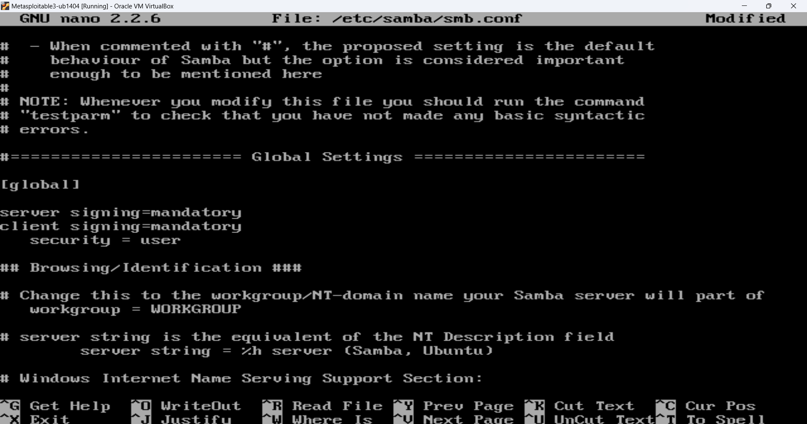

IP Forwarding:
Using the command sudo sysctl net.ipv4.ip_forward, I verified the status of the IP forwarding configuration. 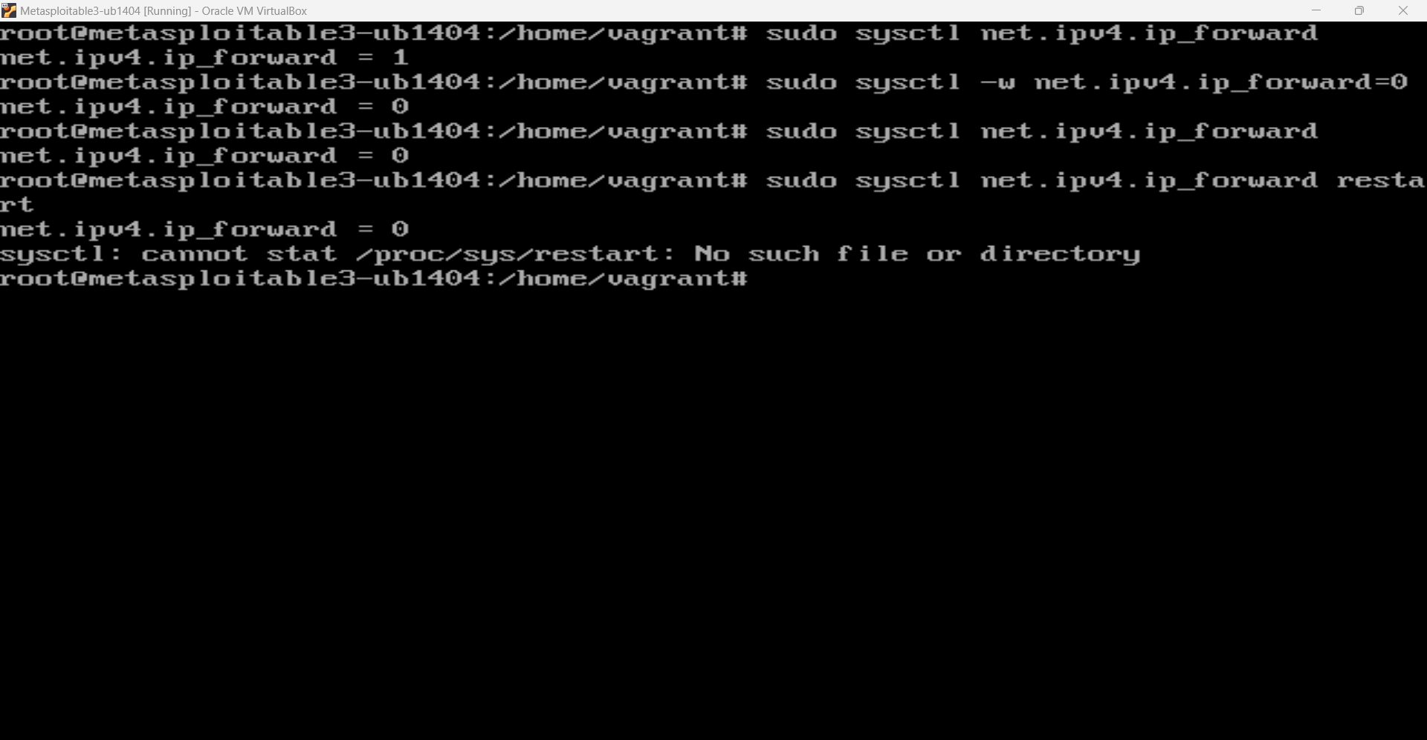

Next, I used the command sudo sysctl -w net.ipv4.ip_forward=0 to deactivate IP forwarding by setting the value of net.ipv4.ip_forward to 0. I updated the /etc/sysctl.conf file with the configuration to make sure it would hold up through reboots.

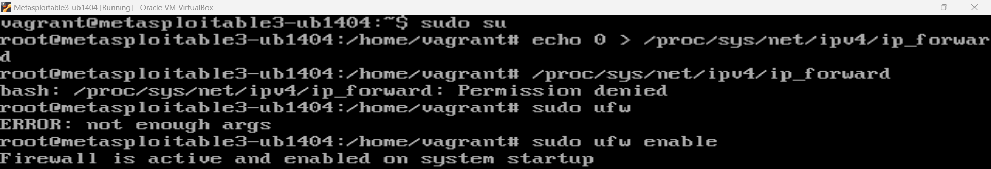
Using the command sudo ufw enable, I also turned on the Uncomplicated Firewall (UFW) for further network security which solves this vulnerability

Outdated software versions:

Php: Outdated PHP version leading to several vulnerabilities.
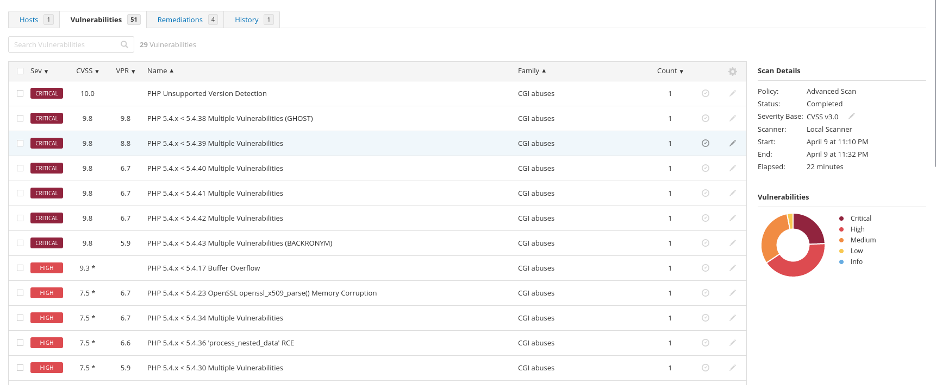
Using the command “php -v”, I first verified the version of PHP that was running. To get the most recent details on the packages that were available, I then used “sudo apt update” to update the package lists along with “Sudo apt install software-properties-common“ I then used “sudo apt upgrade php” to update PHP to the most recent version. I used “php -v” to check the installed PHP version after updating to make sure everything went well.
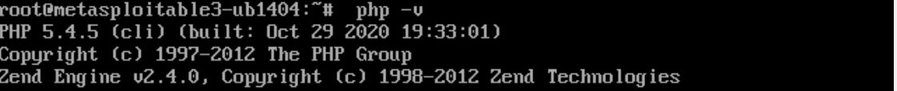
Finally, I used “sudo systemctl apache2 restart” to restart the webserver to implement the modifications and guarantee that the upgraded PHP version would function properly and remove all the vulnerabilities associated with it

Drupal version update:
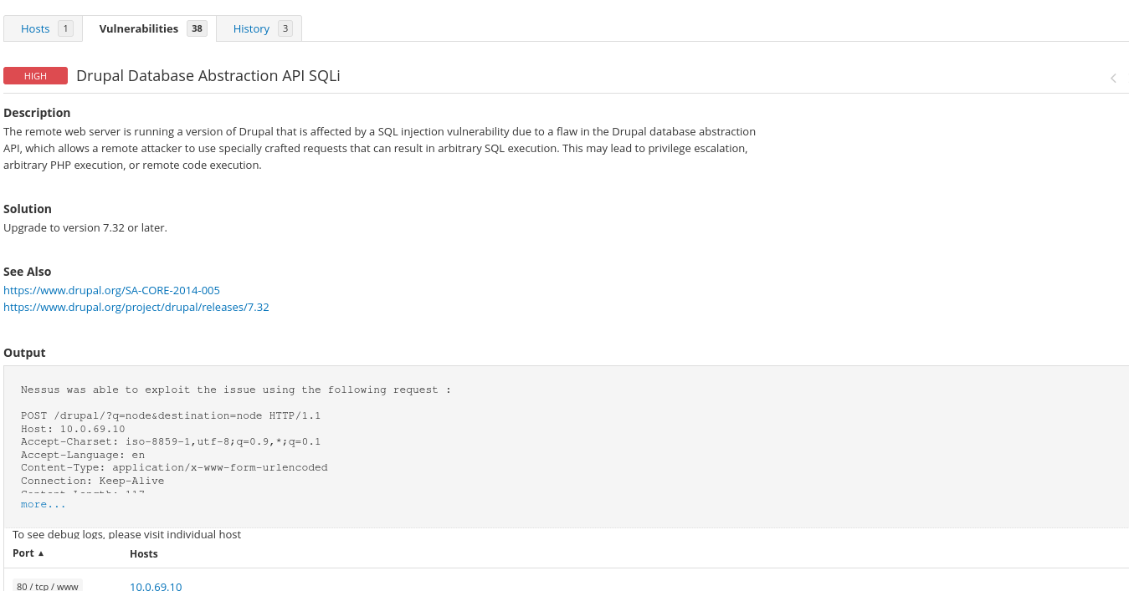

Using the wget command, I started by downloading the most recent version from the official phpMyAdmin FTP server: wget https://ftp.drupal.prg/files/projects/drupal-7.32.tar.gz
After the download had finished, I used tar -xzvf phpMyAdmin-7.32-all-languages.tar.gz to extract the file.
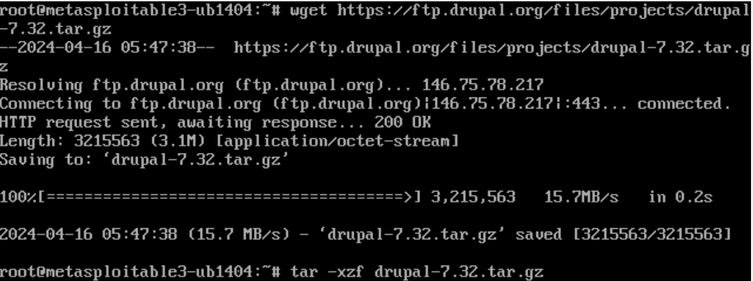
I then moved the existing drupal and replaced it with the downloaded version of drupal
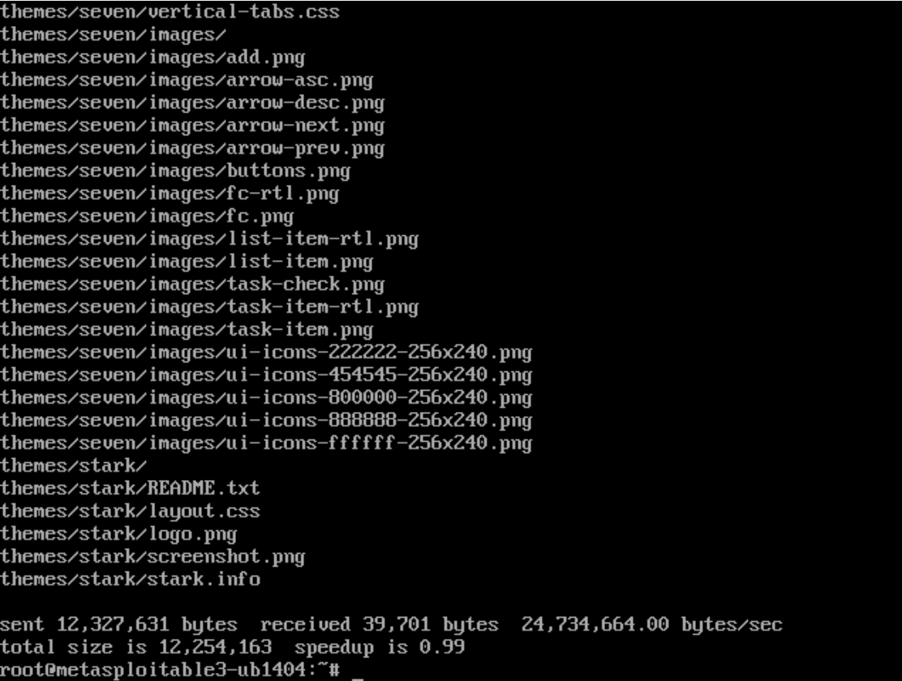. I checked the configuration file to make sure everything was set correctly before completing the update and restarting the web server by running sudo systemctl restart apache2 to make the changes take effect.
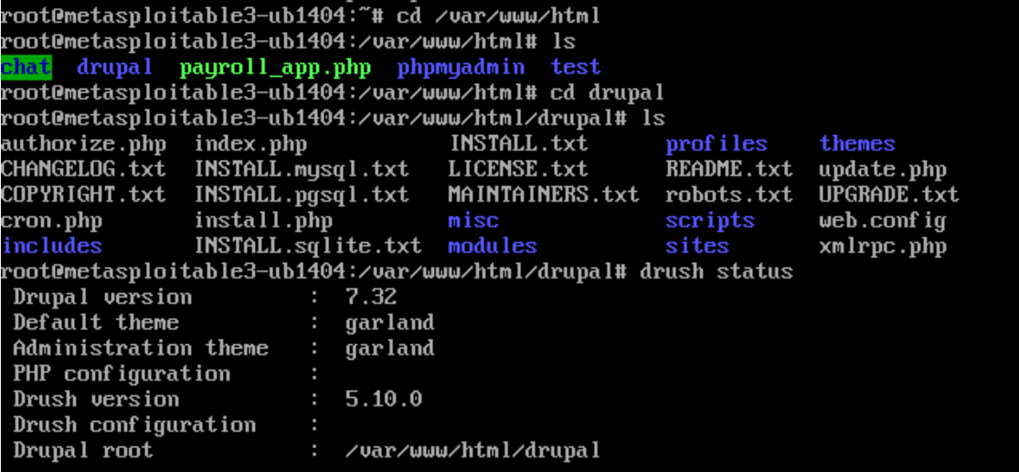

Web application clickjacking:

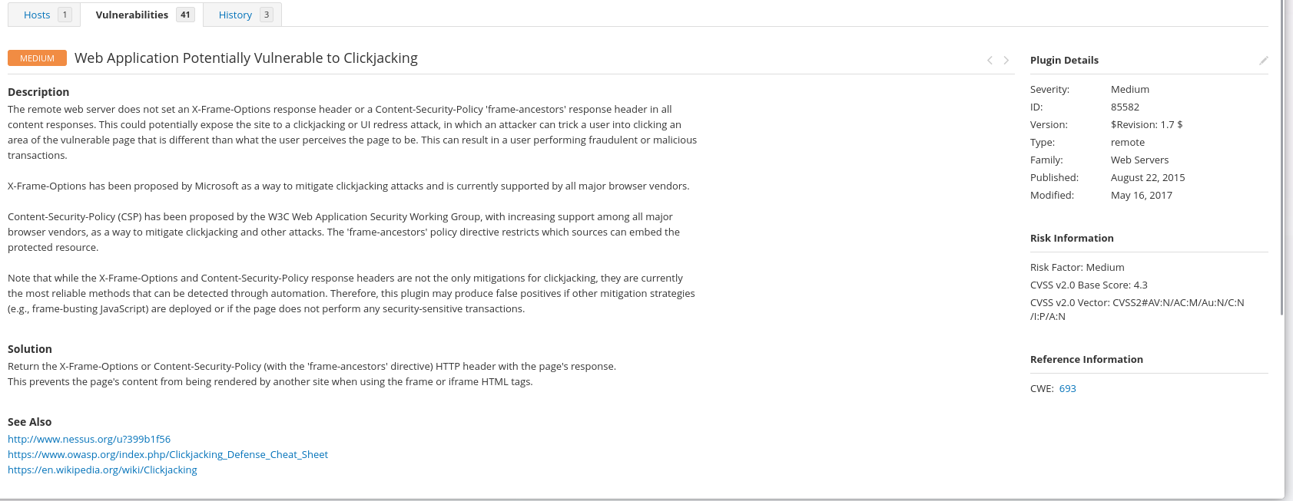
I updated the.htaccess file in the /var/www/html/ directory with security headers to address the web application clickjacking vulnerability. I went to the /var/www/html/ directory and used vi.htaccess to open the.htaccess file for editing in order to reduce this danger. To prevent the web application from being embedded in iframes, I added the lines Header always set X-Frame-Options "SAMEORIGIN" and Header always set Content-Security-Policy "frame-ancestors ‘self’” to the.htaccess file.
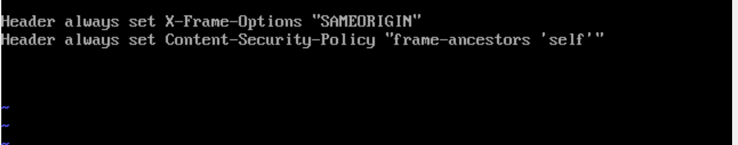

I saved the file and closed the editor after modifying. By blocking attempts to embed the program within iframes, this setting successfully defends the web application from clickjacking assaults.

Browsable Web directories:

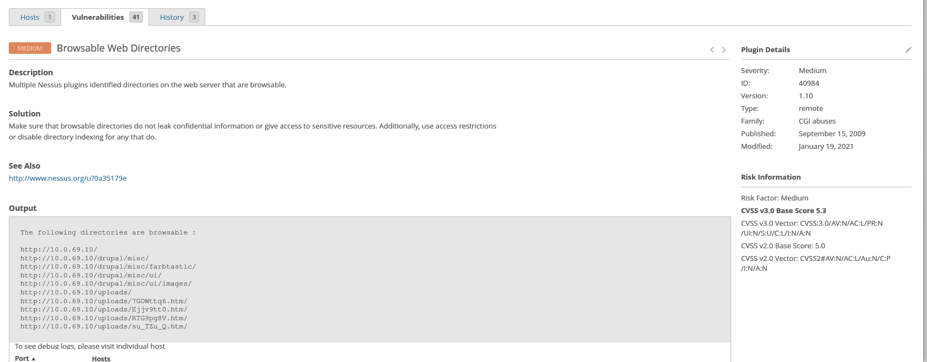

To fix browsable web directories and improve web server security, I turned off the autoindex module, which stops the server from showing directory listings. To firmly disable the autoindex module, I used the “sudo a2dismod --force autoindex” command.
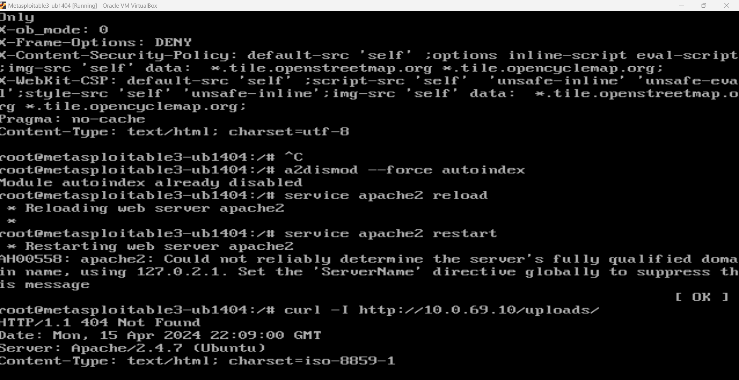

Using the command sudo service apache2 restart, I restarted the web server after disabling the module to ensure the modifications took effect, and the web directory is not browsable as shown in the figure above where we get 404 not found, which solves the issue.

Web Server Allows Password Auto-Completion:

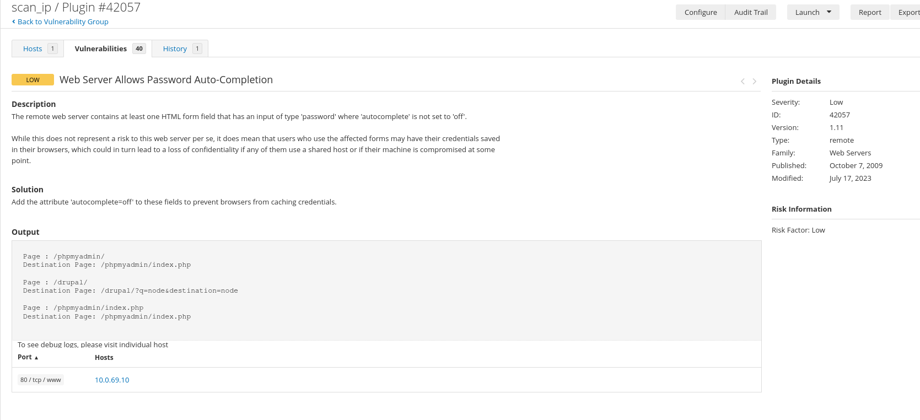
I managed to resolve this vulnerability using sudo nano default-ssl.conf
And added the Header lines inside the <Virtual Host> block which managed to remove the issue.

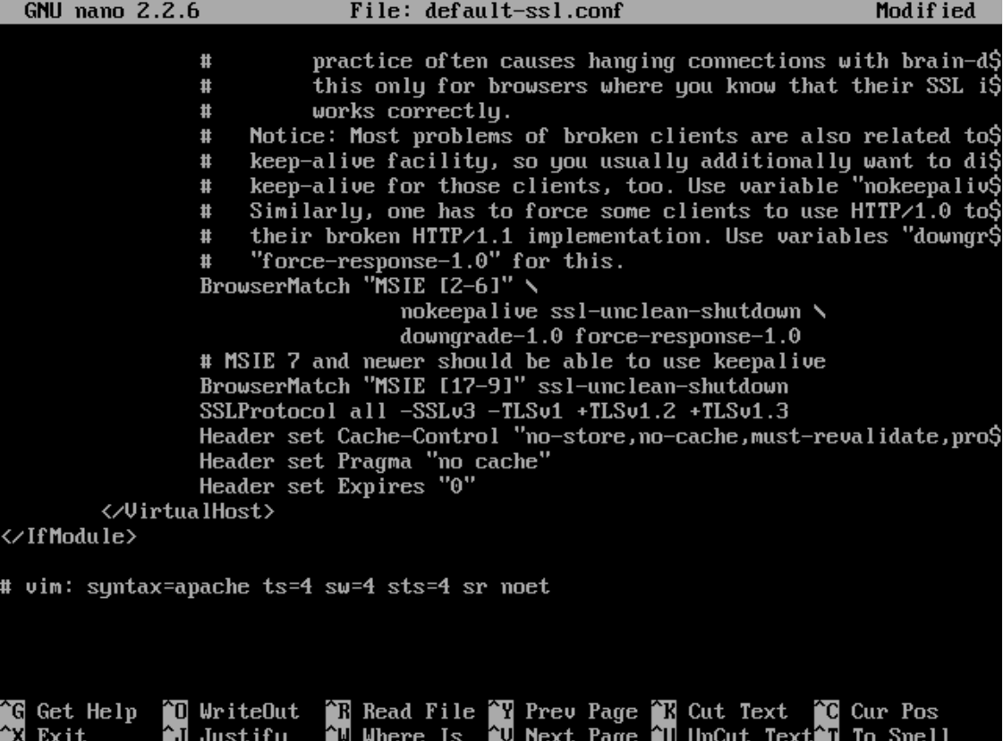

Conclusion:
I have successfully fixed the security flaws in the Metasploitable 3 virtual machine, but I encountered SSL/TLS vulnerabilities because of compatibility issues with Metasploitable version 3. After fixing the vulnerabilities, I ran a scan again through Nessus to check the vulnerabilities and managed to secure my machine to a great extent.(Post Fix scan_Metaspolitable, n.d.)

References and Appendix:

Metasploitable scan_Vulnerability pre-fix scan. (n.d.).
Post fix scan_Metaspolitable. (n.d.).

